IKEA Quad Style Dining Set

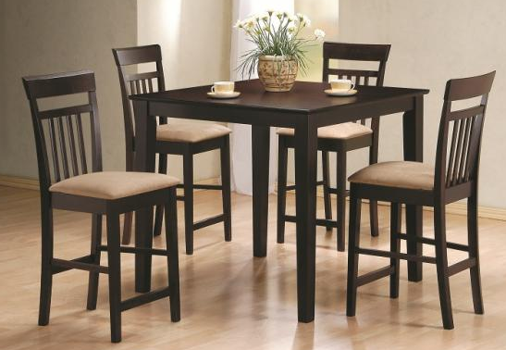

|  |
| --- |
| **DESCRIPTION** |
| IKEA introduces stylish wooden formed dining set with interior finish. One square table with four long chairs makes it perfect for a dinner to create a perfect look for family gathering. The rich polished top and a detailed sheet of designs change the look of the table into a complete new modified version at affordable rates. |

|  |  |  |
| --- | --- | --- |
| **Price** | **1200$** | |
| **Dimensions** | **Table H** x **W** x **L** | **45in x 40in x 40in** |
| **Chairs H** x **W** x **L** | **35in x 16in x 16in** |
| **Features** | **Four Chairs and One square shaped Table with form on top provides a comfortable environment and relaxes your entire body long table helps to adjust feet according to the shape.** | |
| **Finished** | **Polished Interior Shine** | |
| **Available in** | **Brown and Dark Blue.** | |